NAME: Nevetha S K
EMAIL ID: nevethasenthilkumar@gmail.com

DATA LAKE STORAGE INTEGRATION

Table of Contents
- Project Statement
- Project Overview
- Prerequisites
- Azure Resources Used for the Project
- Project Objectives
- Tools Used
- Execution Overview
- Implementation-Tasks Performed
- Practical Implementation on Azure Portal
- Successful Output Generated
- Strategies that can be used in Optimising the Conversion process
- Conclusion

Project Statement:
Data Lake Storage Integration:
Integrate Azure Data Factory with Azure Data Lake Storage. Develop a pipeline that moves data between different folders in the Data Lake, with version control managed through Azure DevOps.

Project Overview:
This project sets up a data movement workflow using ADF that reads from and writes to ADLS folders, while integrating ADF into Azure DevOps for version control and CI/CD. Developers work in Git, use feature branches, review changes via pull requests, and deploy using ARM templates through Azure Pipelines.
Prerequisites:
- Active Azure subscription
- Azure Data Factory resource (Version 2 or above)
- Azure Data Lake Storage (Gen2 recommended)
- Azure DevOps organization, project, and Git repository configured
- Access rights to configure ADF and Azure DevOps pipelines
- Optional: Azure Pipelines configured for CI/CD

Azure Resources Used for this Project:
- Azure Data Factory – as the orchestration and ETL tool
- ADLS Gen2 – to store source and destination datasets
- Azure DevOps Git – for source control of ADF artifacts
- Azure Pipelines – for deploying changes across environments using ARM templates

Project Objectives:
- Move data efficiently between ADLS folders using ADF pipelines
- Maintain version control of pipelines, datasets, linked services in Git
- Implement CI/CD deployment across Development → Test/UAT → Production environments
- Enable rollback, controlled releases, and auditing of changes

Tools Used:

Azure Portal – to author and manage ADF and ADLS
Azure DevOps (Repos, Pipelines) – for Git, CI/CD, and deployment
ARM Templates – for exporting and deploying ADF resources

Execution Overview:

- This project demonstrates the integration of Azure Data Factory with Azure Data Lake Storage to enable efficient and automated data movement across folders within the Data Lake.

- By leveraging ADF pipelines, we orchestrate the transfer, transformation, and organization of data while ensuring scalability and reliability.

- To maintain transparency and collaboration, Azure DevOps is used for version control and CI/CD, enabling teams to track changes, manage pipeline configurations, and ensure consistent deployment across environments.

- This integration showcases how cloud-native tools can streamline data engineering workflows, ensuring secure, automated, and well-governed data management.

Implementation-Tasks Performed:

Step 1: Prepare Azure Resources
This involves creating the necessary resources in the Azure Portal, including:
- An Azure Data Factory instance.
- An Azure Data Lake Storage Gen2 account.
- The folders (containers) within your Data Lake for both your source and sink data.

Step 2: Configure Git Integration in Azure Data Factory
This is a critical best practice for version control.
- In Azure Data Factory Studio, go to the Manage tab.
- Under Source control, select Git configuration.
- Connect your data factory to a Git repository in Azure DevOps, specifying a collaboration and publish branch. This ensures all your work is version-controlled.
Step 3: Create Linked Services
Linked services are the connection strings for your data factory. You must have one to connect to your storage account.
- In the Manage tab, go to Linked services.
- Create a new Linked Service for Azure Data Lake Storage Gen2.
- Enter your subscription and the storage account name.
- Test the connection to ensure it works.
Step 4: Create Datasets
Datasets define the specific data (a file or a folder) that your pipeline will use.
- In the Author tab, click the + button next to Datasets.
- Select Azure Data Lake Storage Gen2 and choose the correct file format.
- Create the Source Dataset: Point this dataset to your source folder in Data Lake and specify the file name or use a wildcard (*.pynb).
- Create the Sink Dataset: Point this dataset to your destination folder in Data Lake.
Step 5: Build and Configure the Pipeline
The pipeline orchestrates the data movement.
- In the Author tab, click the + button next to Pipelines.
- Drag a Copy data activity onto the pipeline canvas.
- Click the Copy data activity and go to the Source tab.
- Select the Source Dataset from the dropdown.
- Go to the Sink tab and select the Sink Dataset.
Step 6: Debug and Publish
- Validate your pipeline to check for any configuration errors.
- Debug the pipeline by clicking the Debug button. This runs the pipeline without deploying it, allowing you to check for errors and verify the data move.
- After a successful debug run, Publish your changes. This deploys all linked services, datasets, and the pipeline to the live Data Factory service and pushes the changes to your Git repository's adf_publish branch.
Step 7: Verify and Monitor
After publishing, go to the Monitor tab to see your pipeline runs.
You can Trigger Now to manually run the pipeline or set up a trigger for automation.
Finally, check your Azure Data Lake Storage to confirm the file has been moved to the destination folder.

Practical Implementation on Azure Portal
Step 1: Create a Storage Account
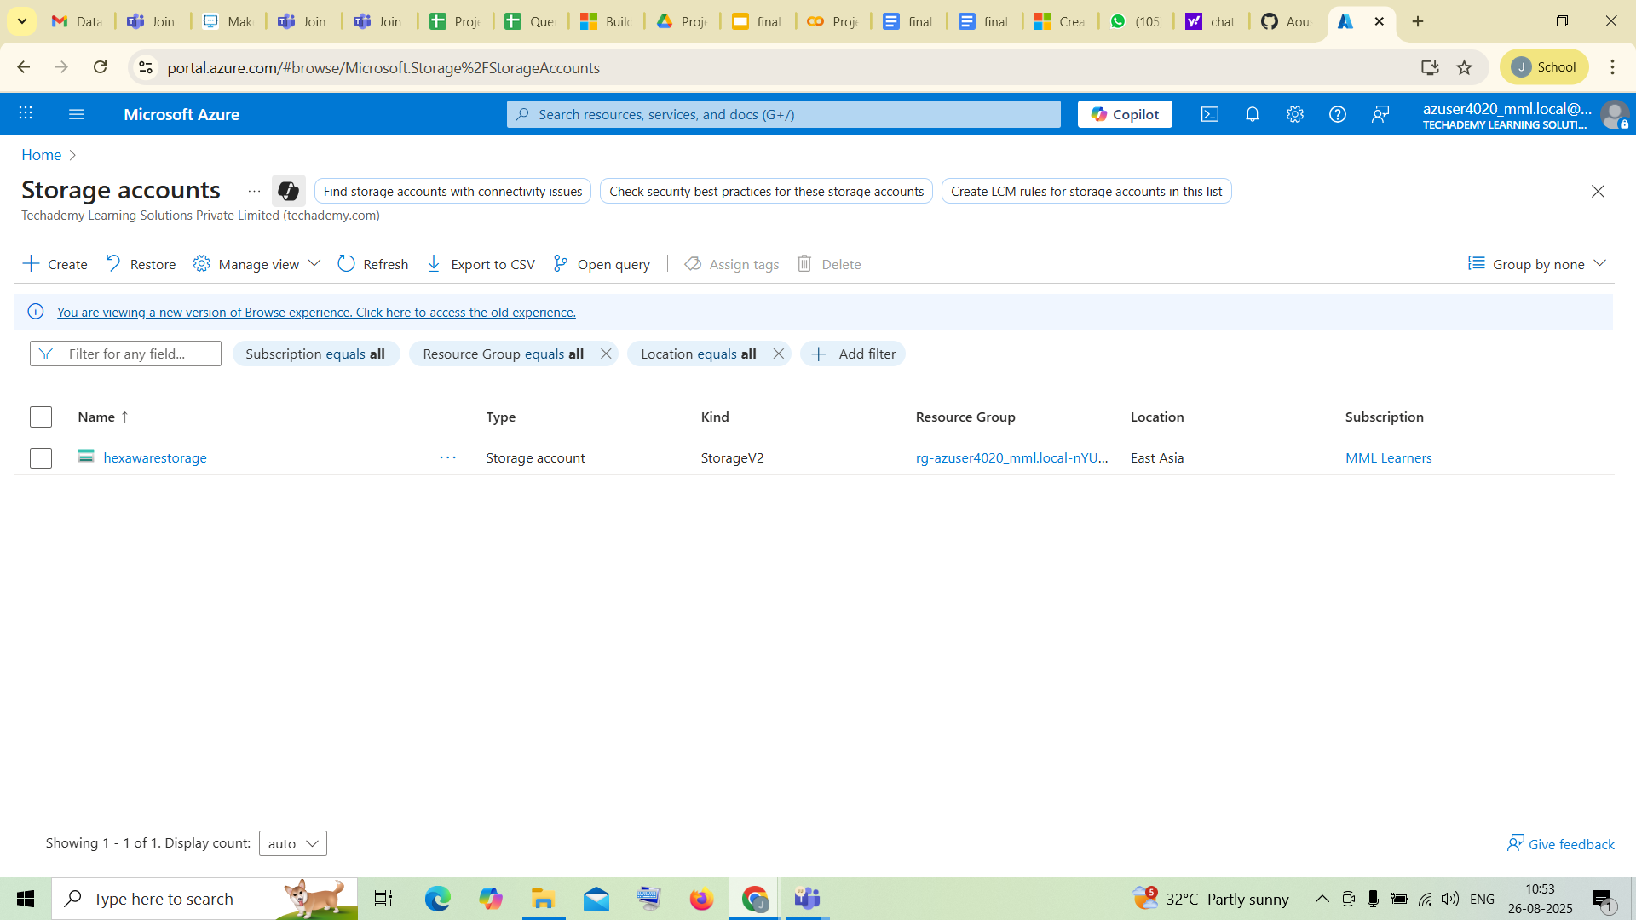
create a storage account by clicking +create
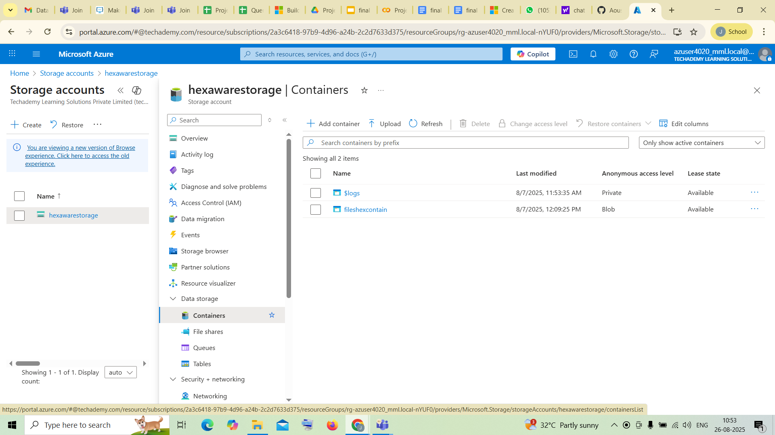
Inside the storage account you can find containers,within the dropdown of data storage
open it

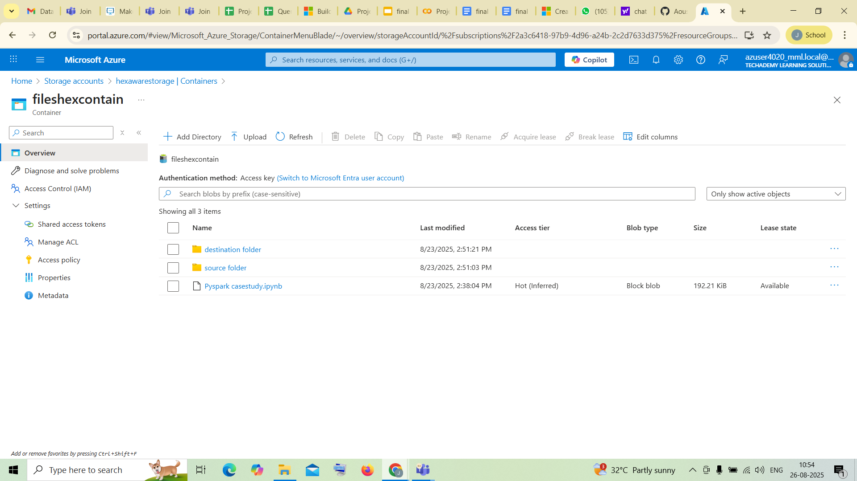

Inside the containers you have to create two folders named source and destination folders

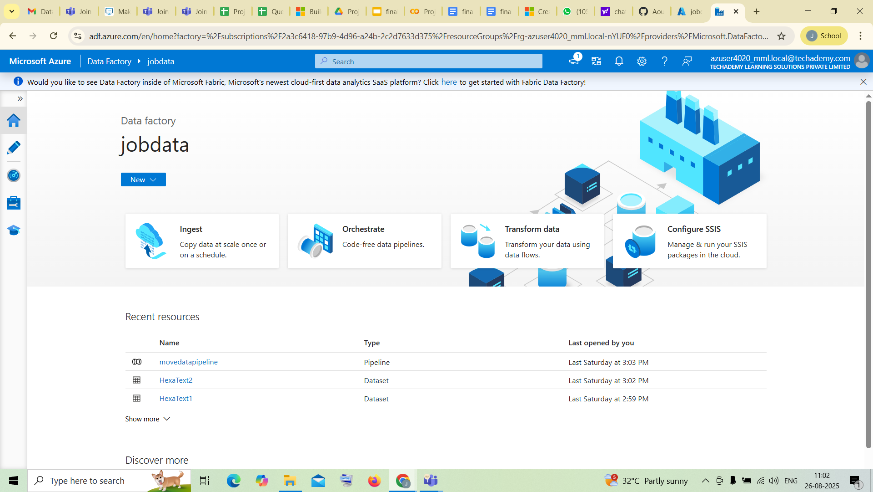
After that open Azure Data Factory ,create a data factory in it and launch the Azure Data Factory Studio by clicking the Data Factory that you have created

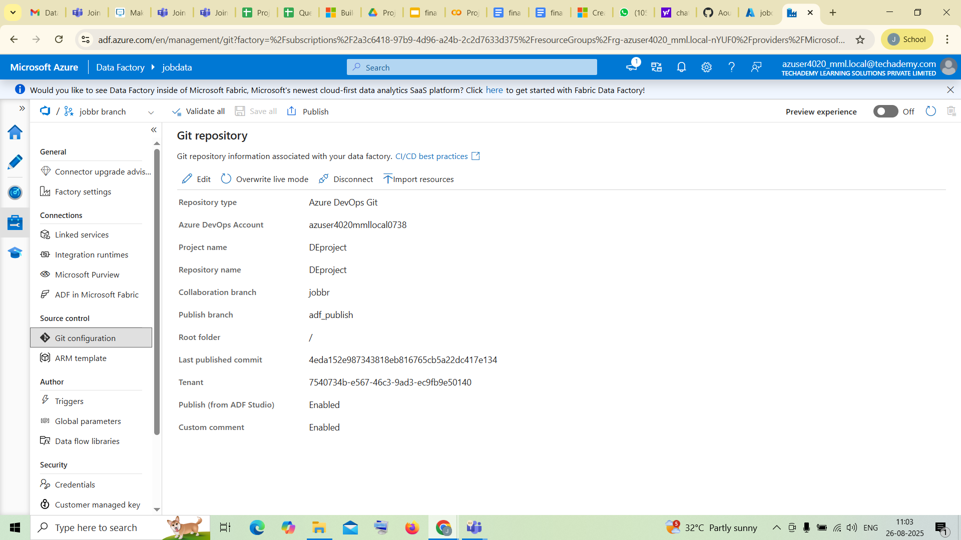
On the left menu, open Manage
under source control you can find Git Configuration
Just connect it

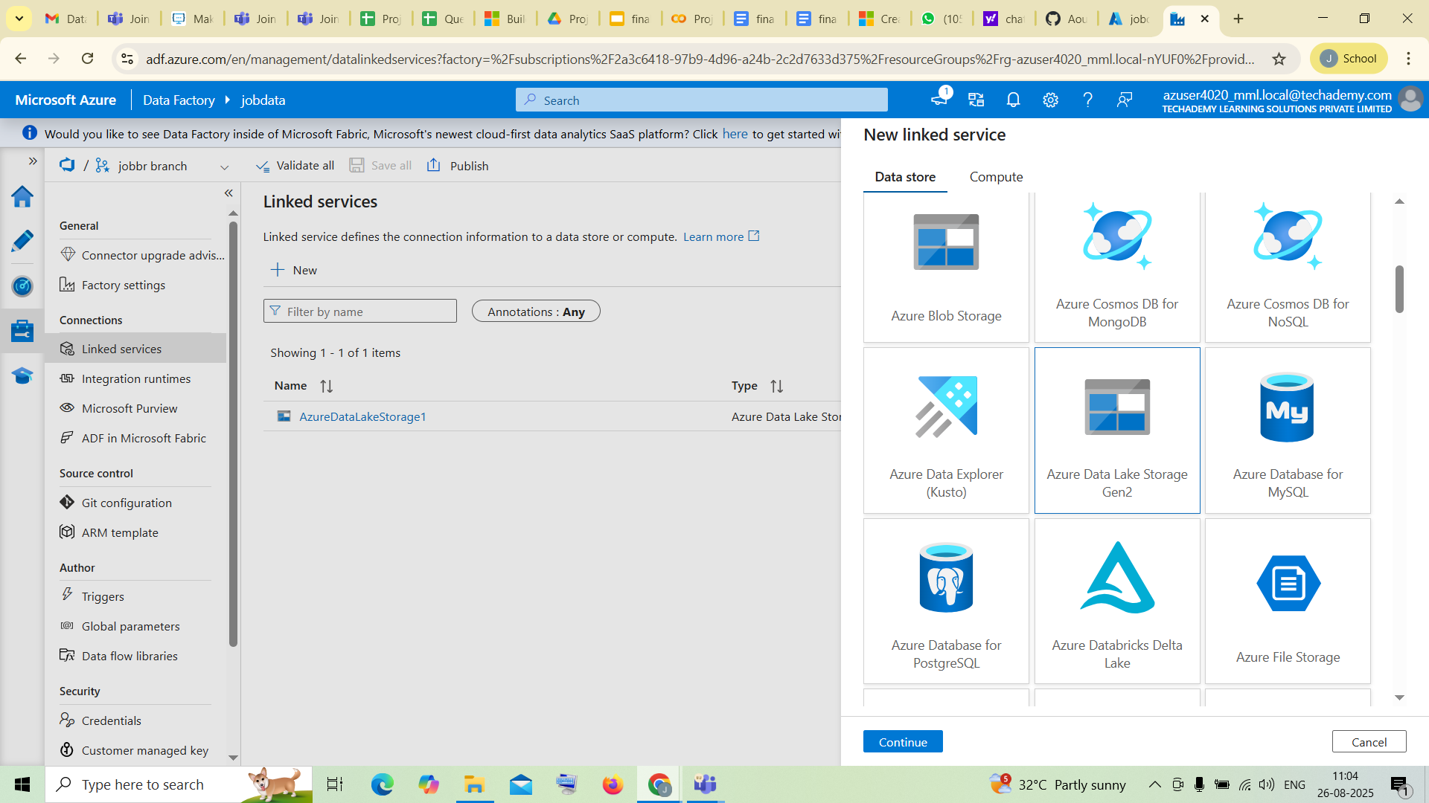
In the same Manage tab,
open LInked Services
Create a new Linked Service (i.e Azure Data Lake Storage Gen2)
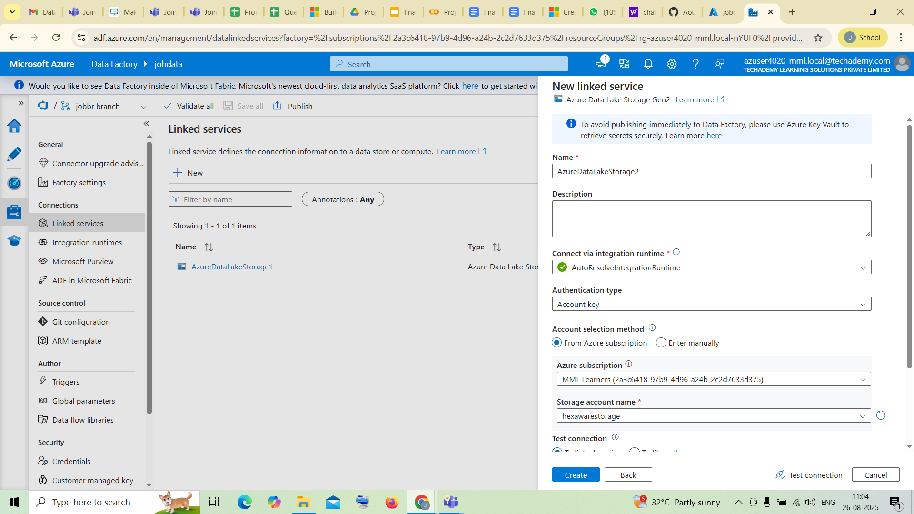
Specify Azure Subscription and Storage account name
and then click on create

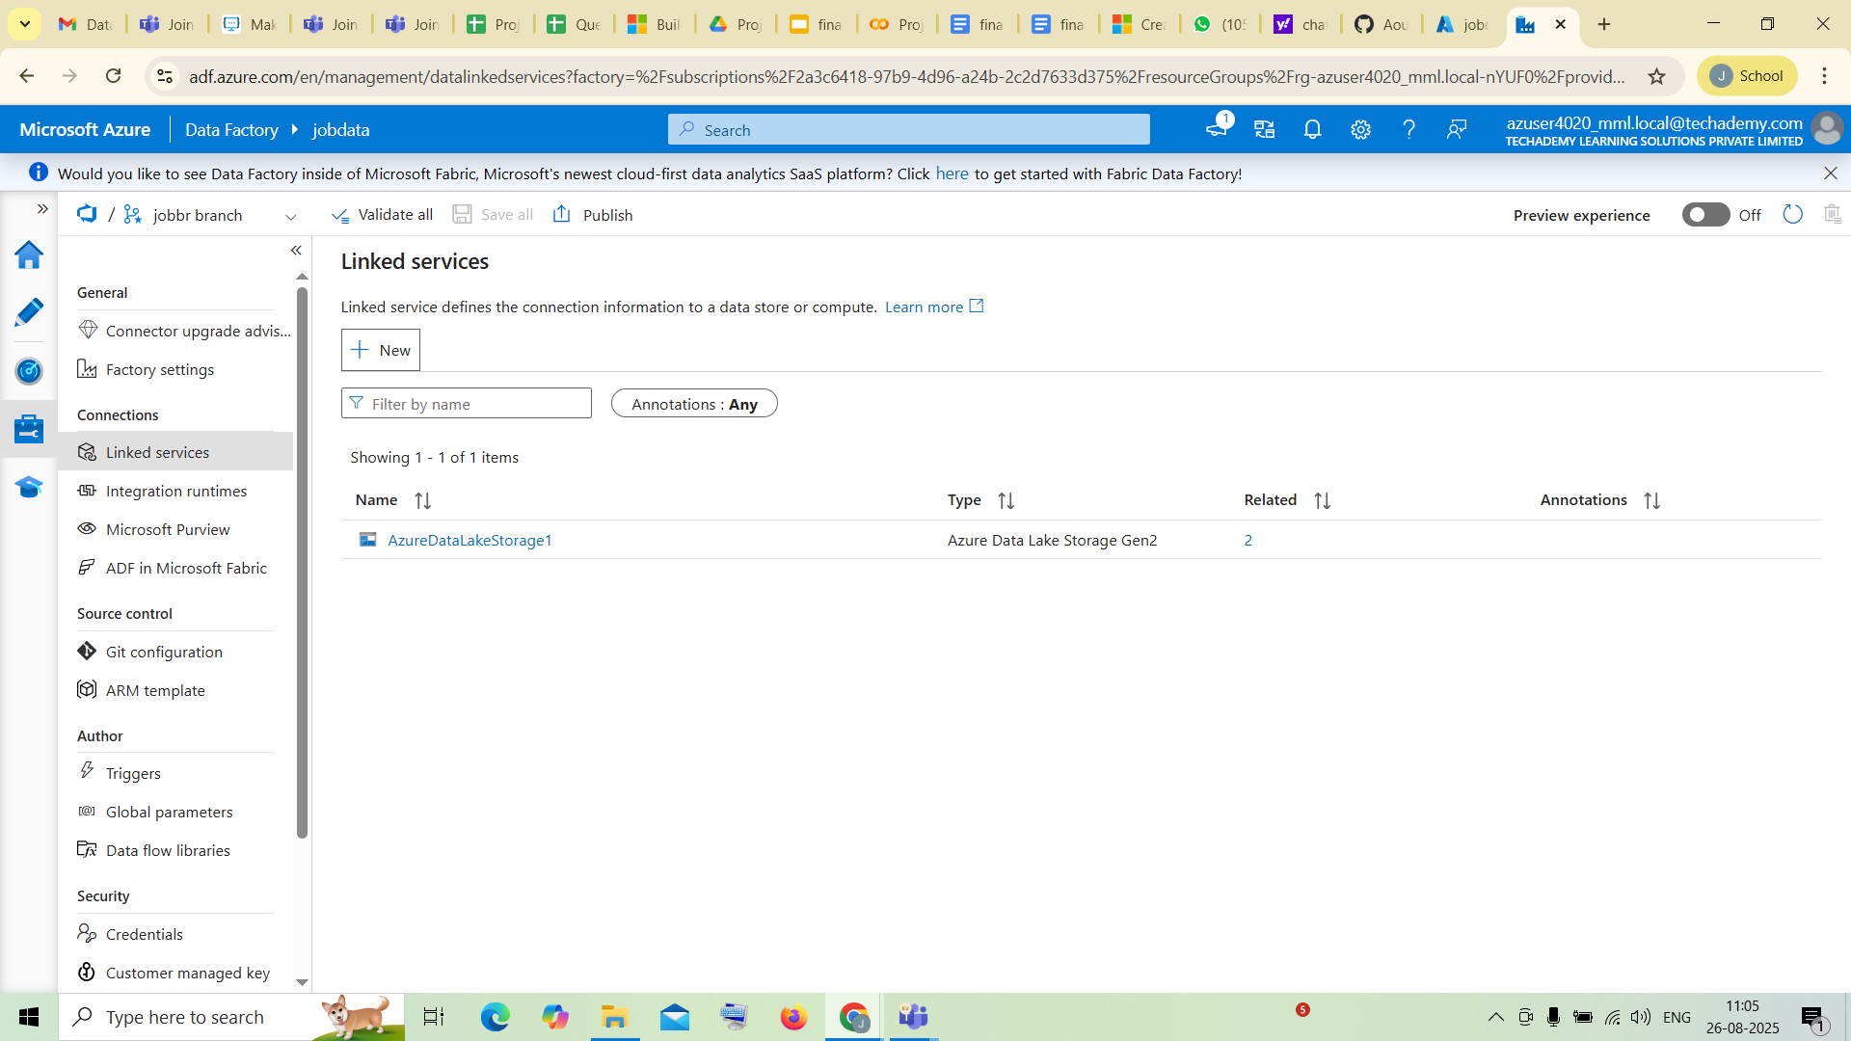
Now you can see your created Linked Services

After that, open Author tab
Create two datasets by clicking + on top, one for source and another for destination,inside those dataset upload correct file which you wanna move to the another folder(sink)
choose Azure Data Lake Storage Gen2
choose the file format that you want to upload and then it will direct you to the container the you should select the file which you want to move to the destination(for source dataset)
same for destination dataset too you want to specify the folder to receive the file
by the time of creating itself
here,
HexaText1 - Source
HexaText2 - Sink

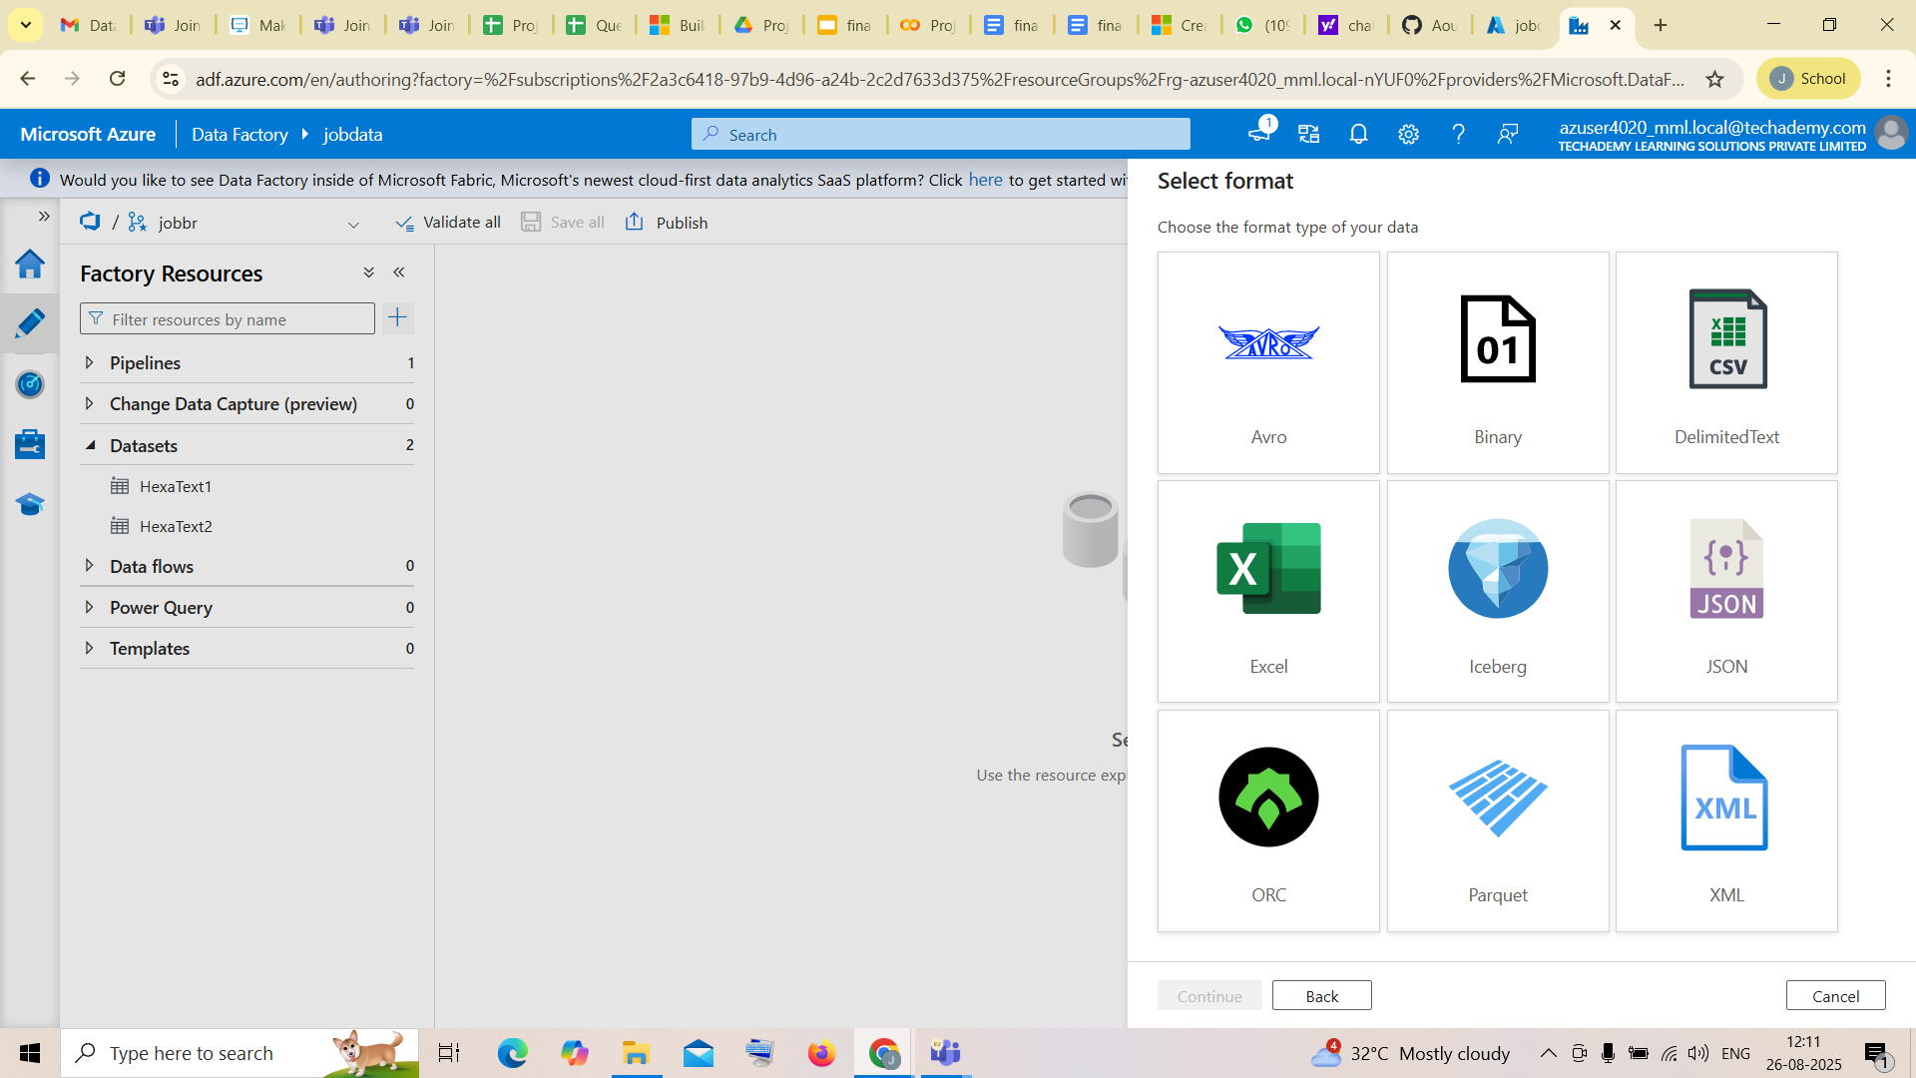

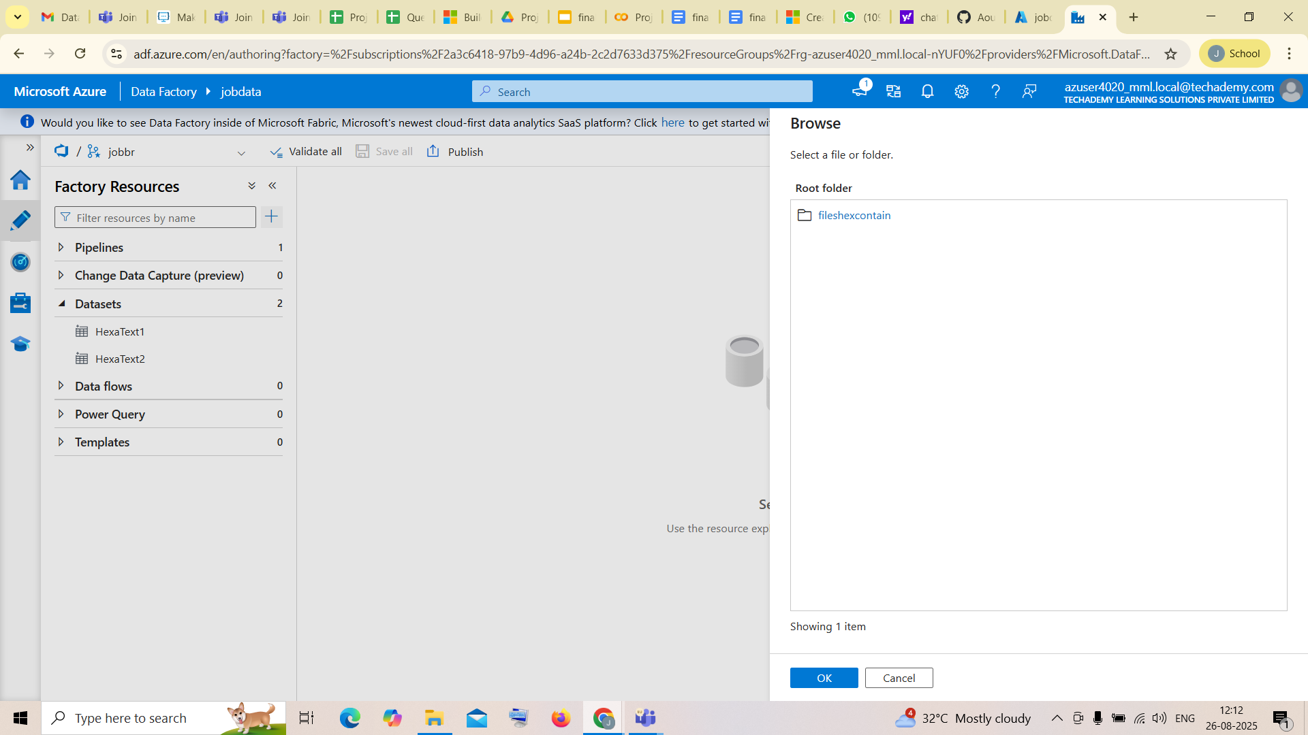
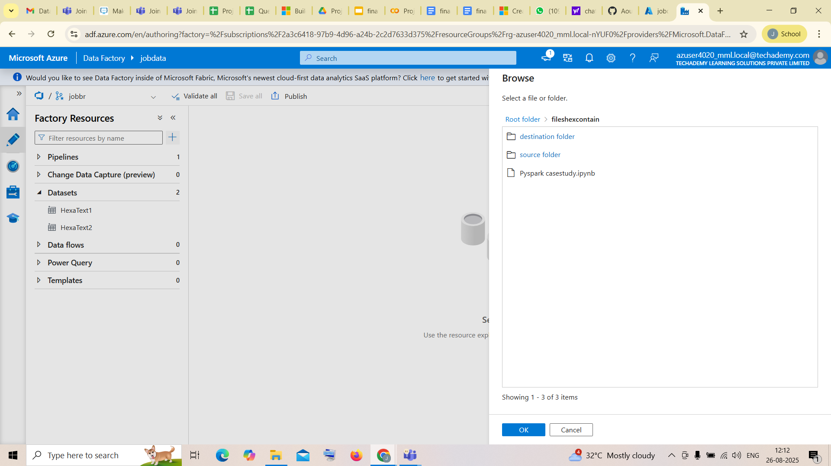

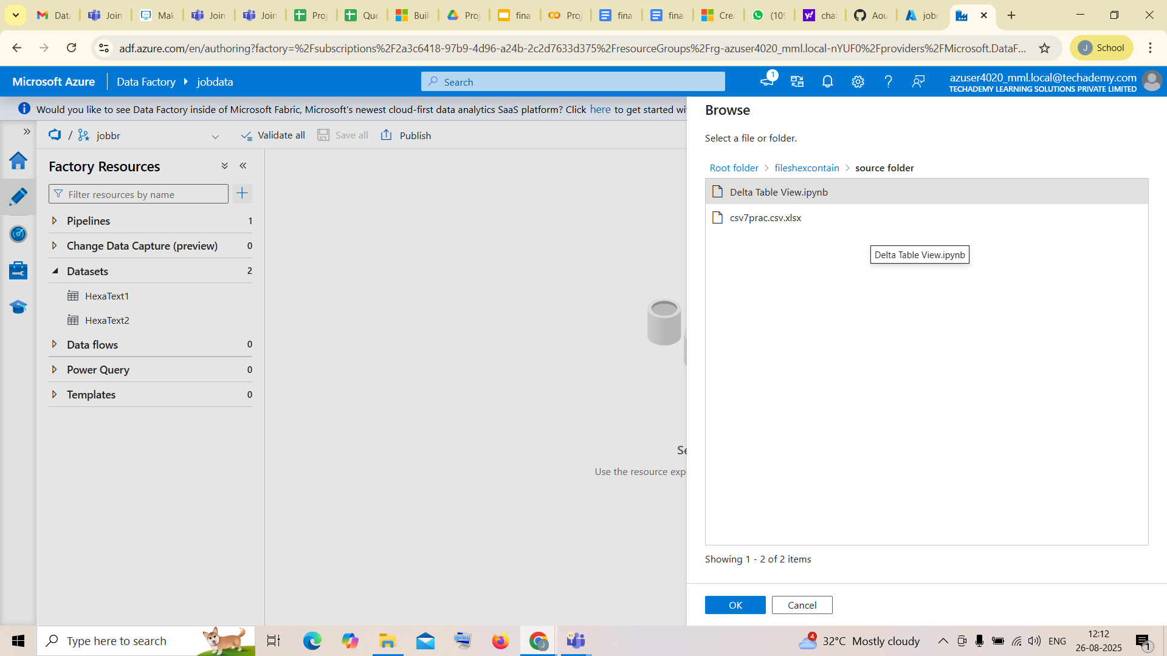

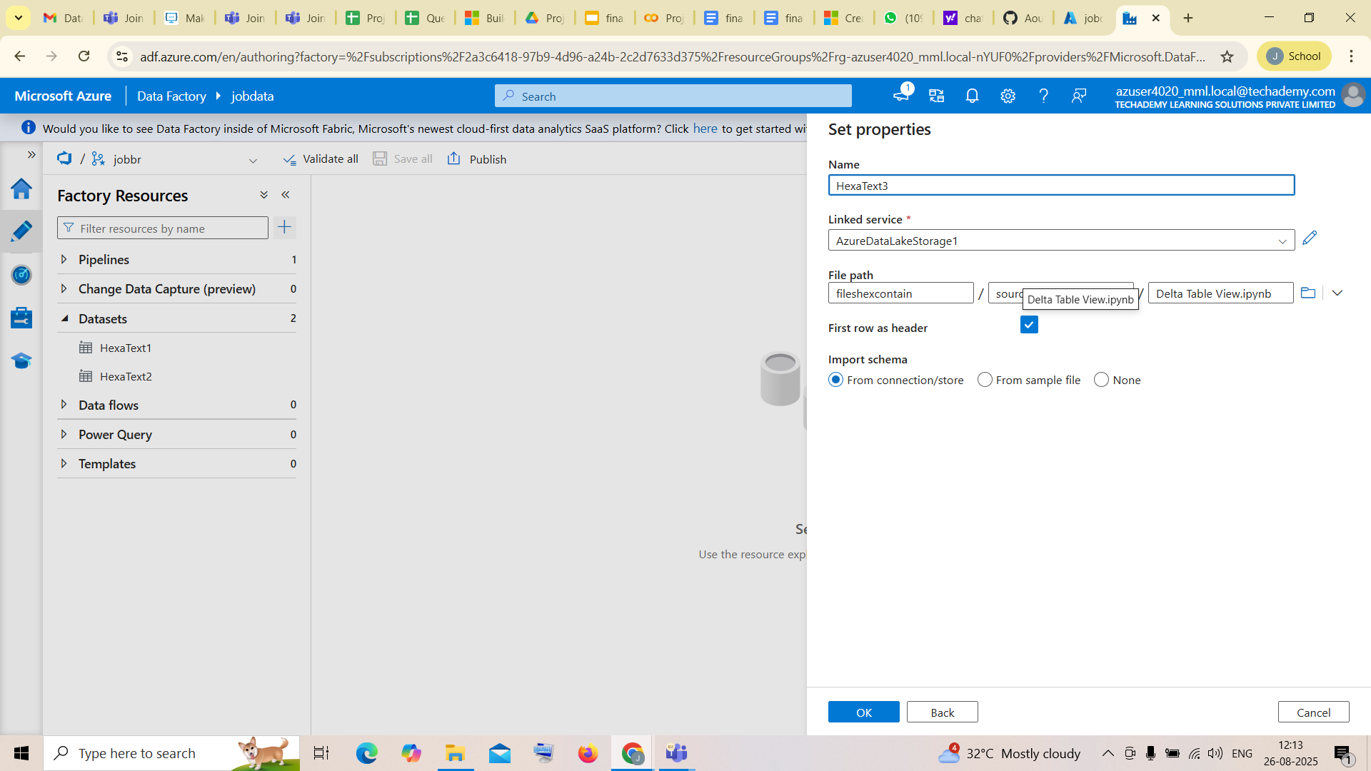

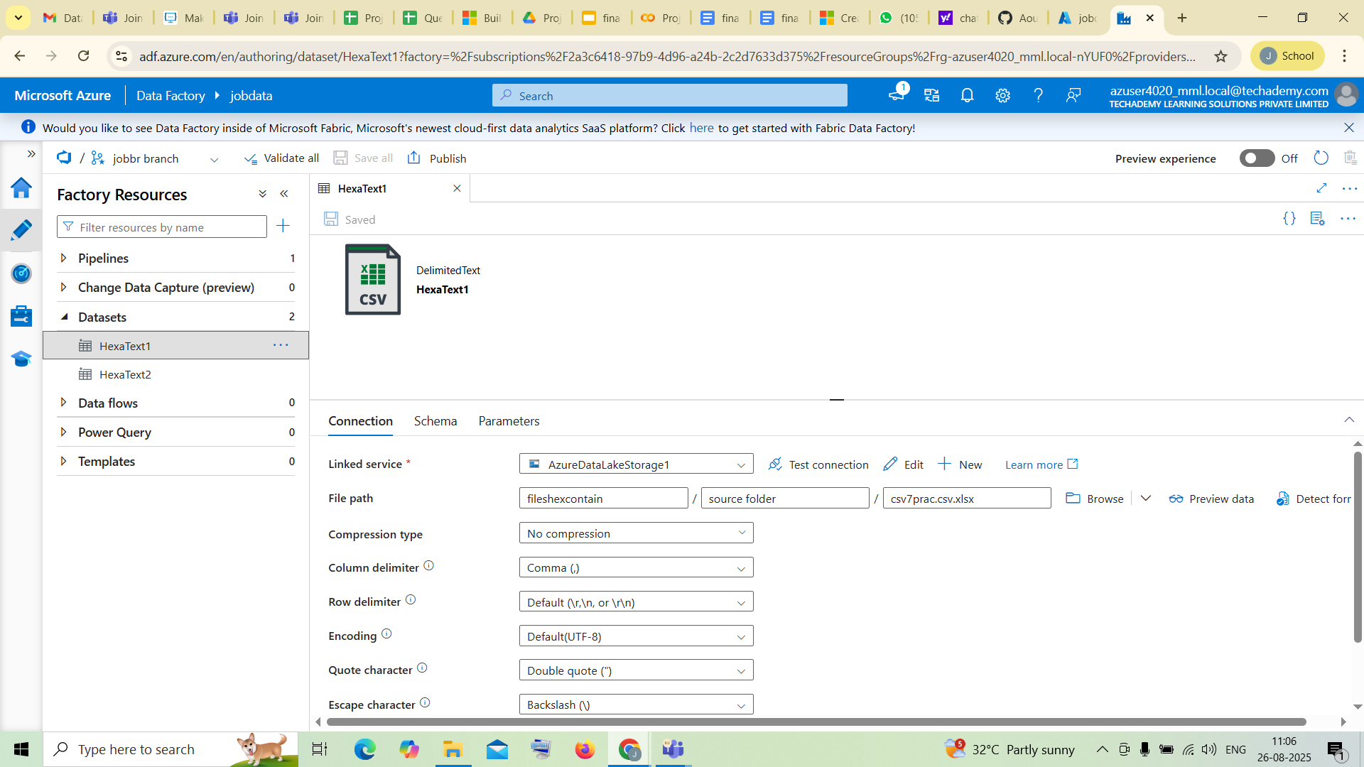

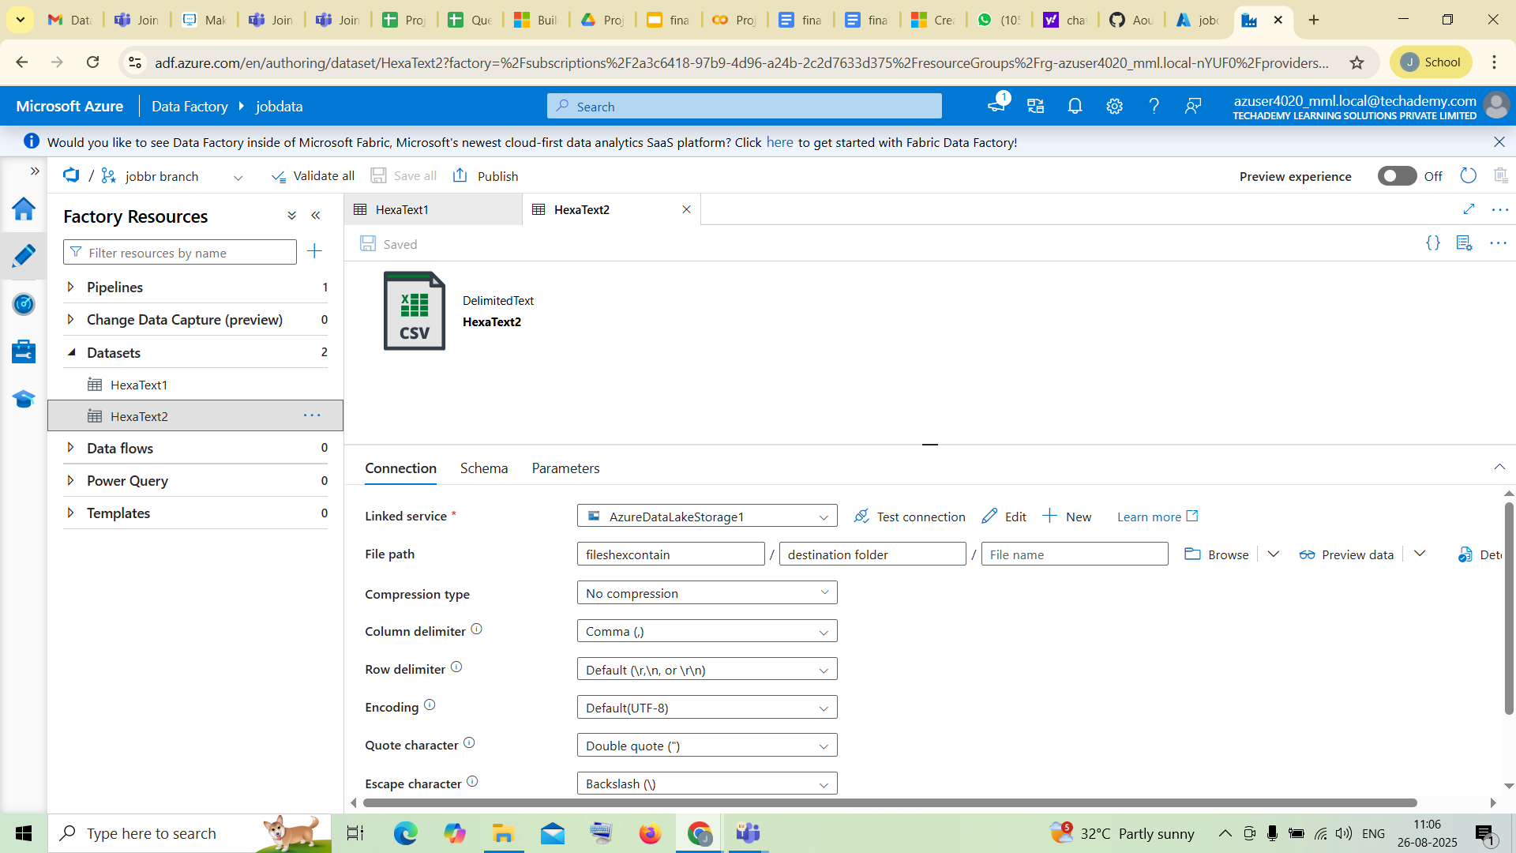

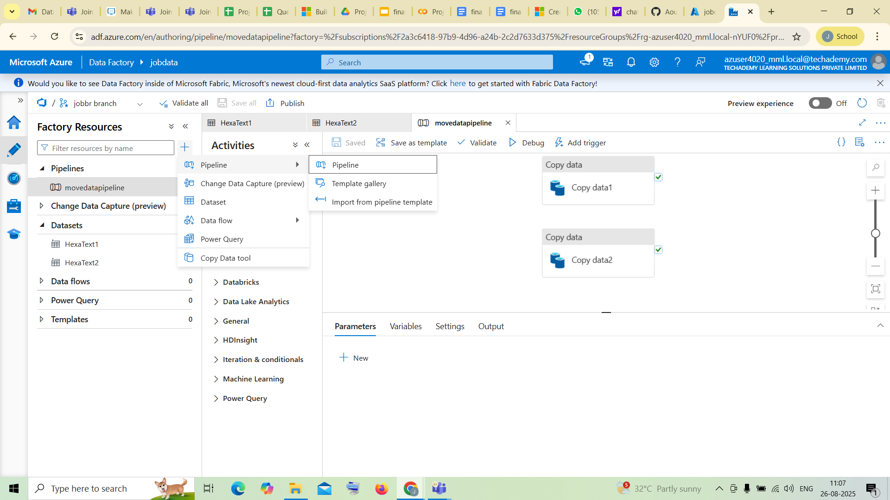
Now by clicking the same + create a new pipeline and drag the copy data to the file

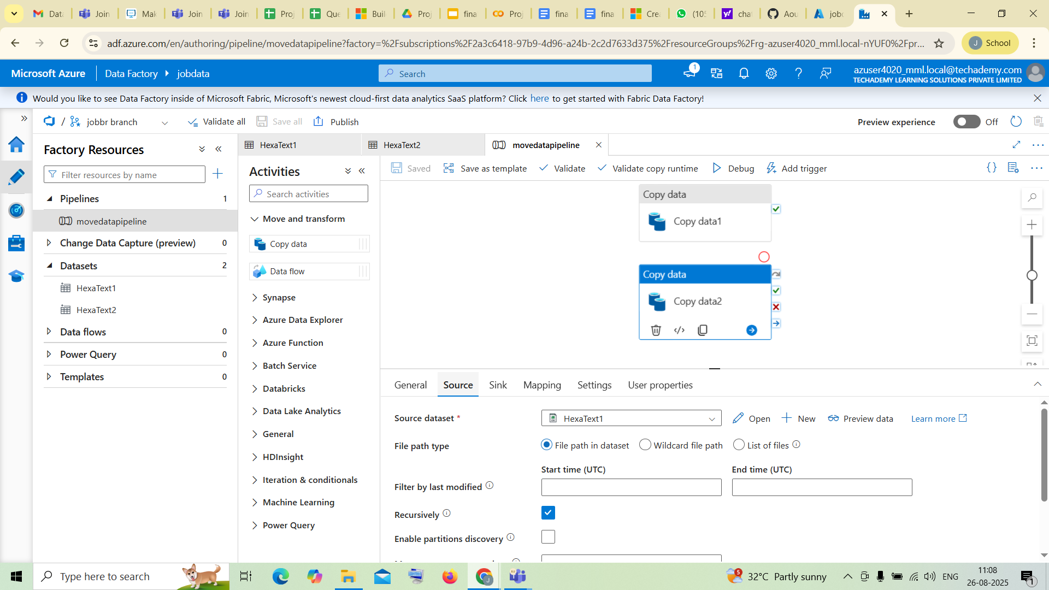

Click on copy data and verify the properties of the source and sink file
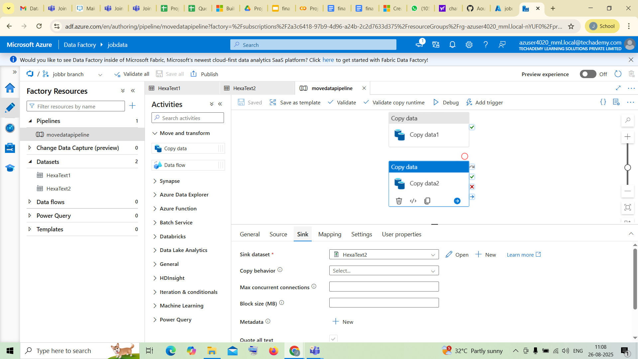
Now click on save all

.

Successful Output Generated:
- ADF pipelines that reliably copy data between designated folders in ADLS
- Source control history tracking all pipeline changes and deployments
- Automated environment promotion with visibility, approvals, and traceability
- Versioned deployments that support rollback and auditing

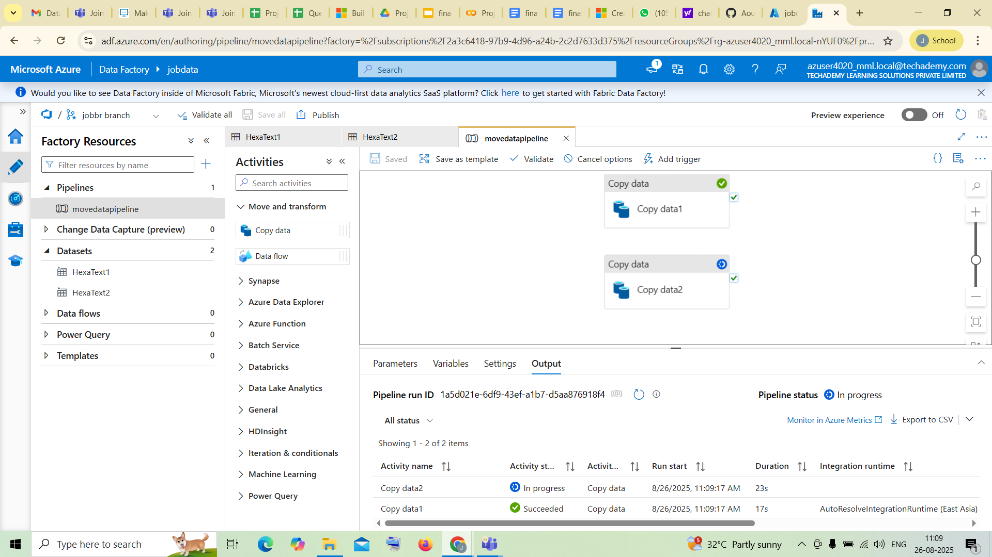
Give Debug on the top
here you can see that the copy data1 is running successfully
after it runs successfully Publish it by clicking on publish on top
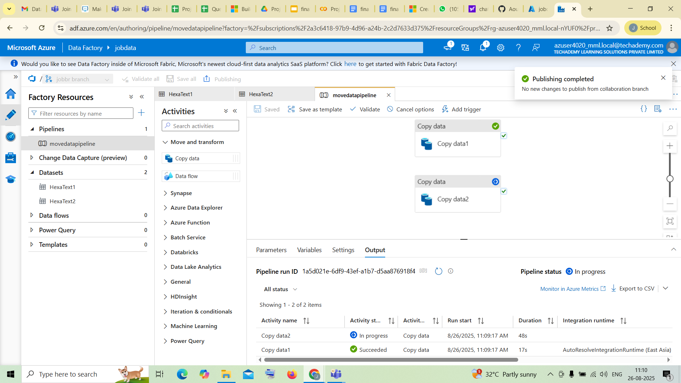

you’ll get a notification that Publishing Completed

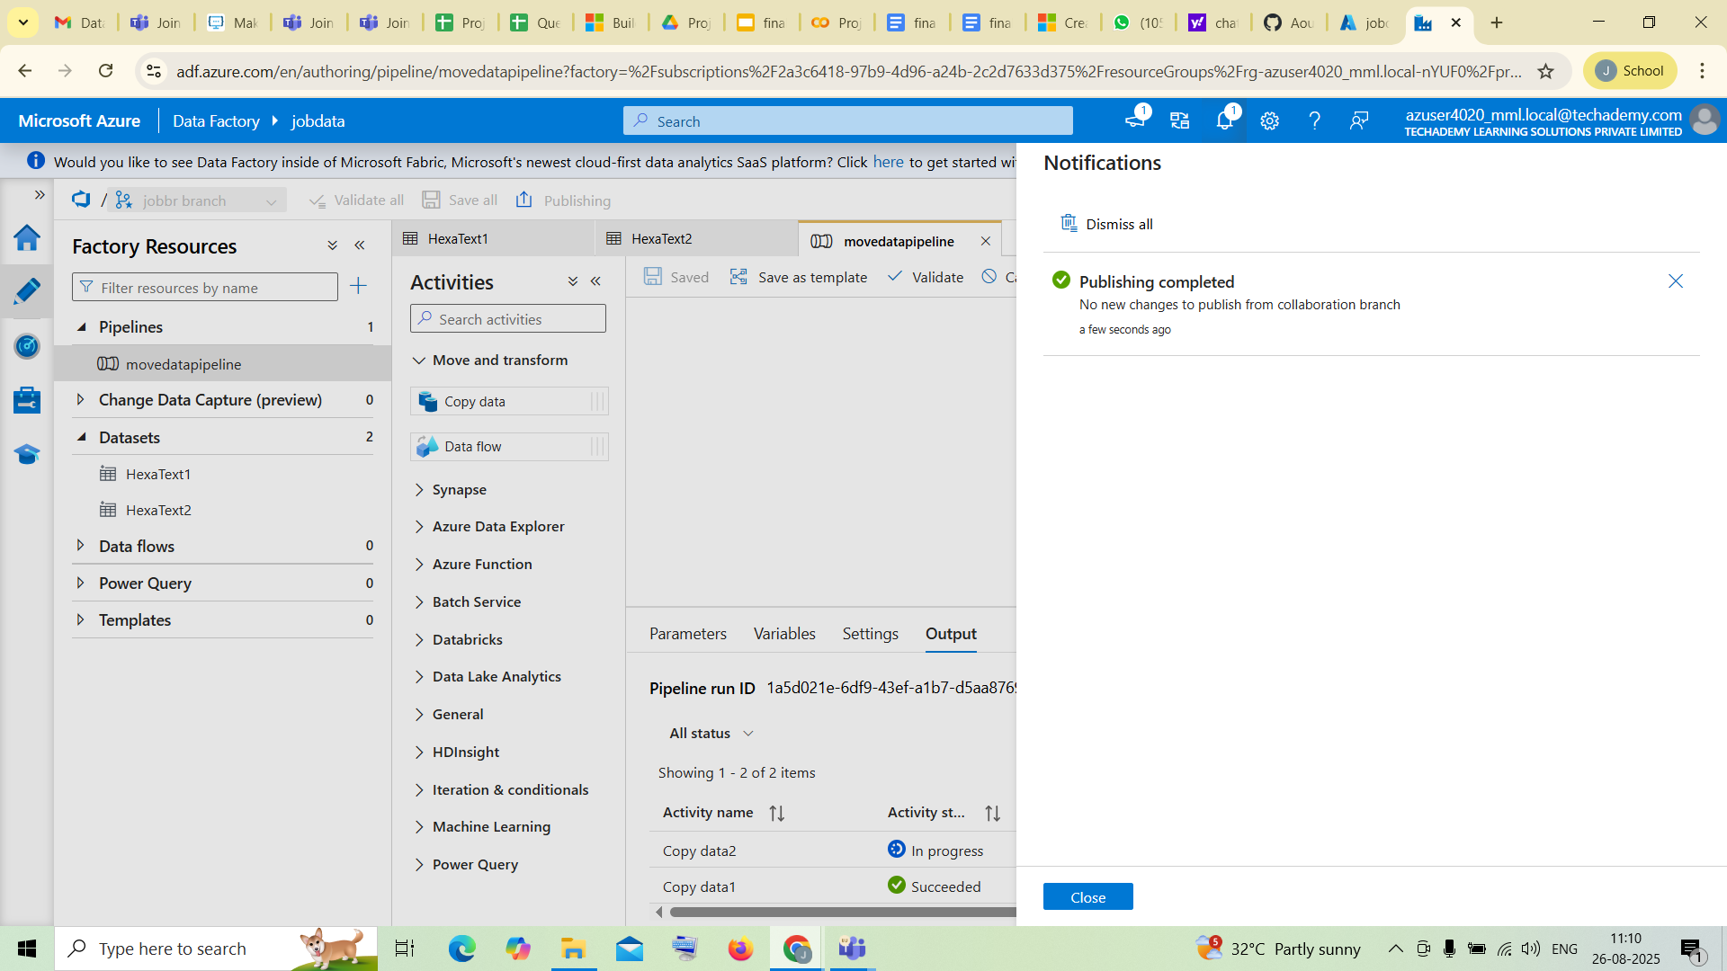

you can verify it in notification tab too

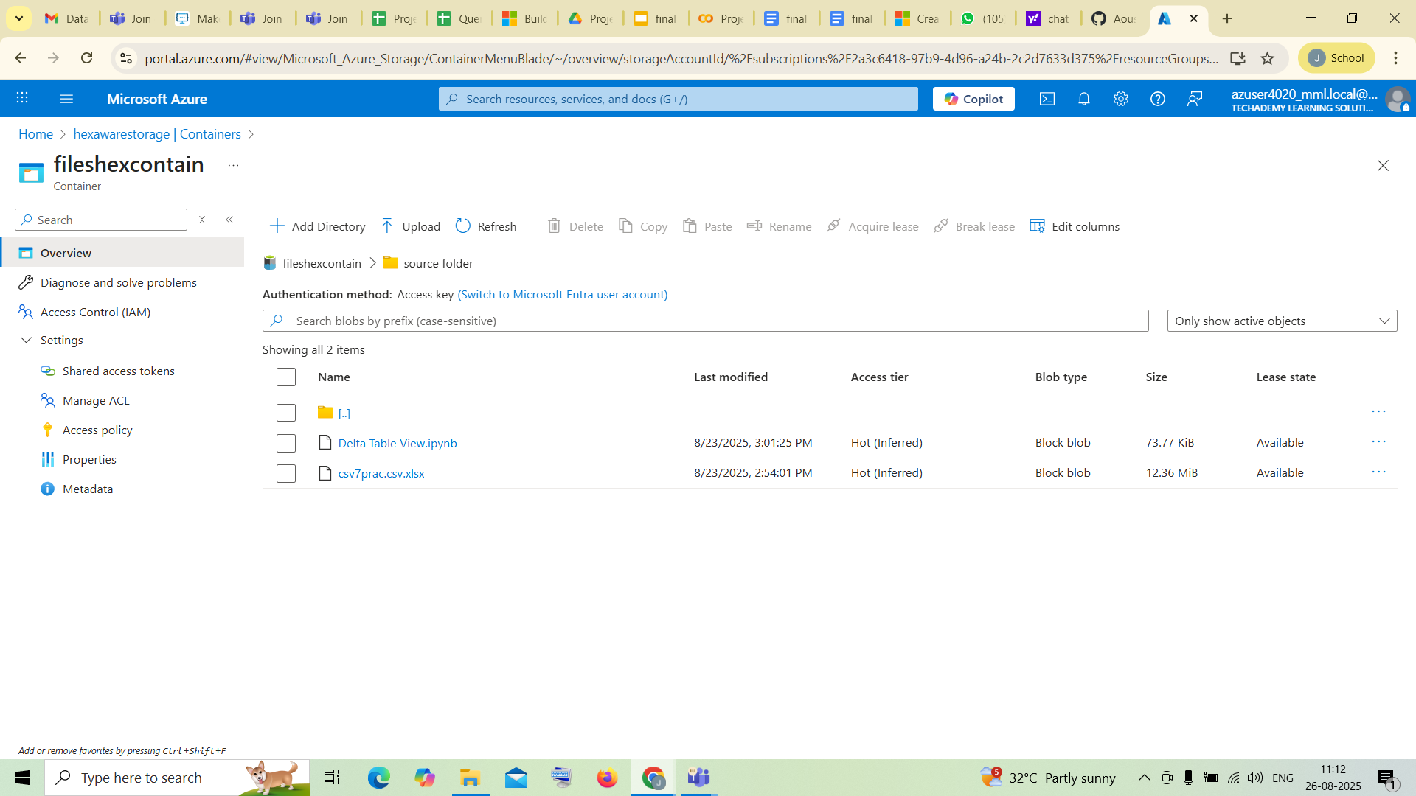

After publishing , open your Storage Account and verify that your file is present inside your destination folder.

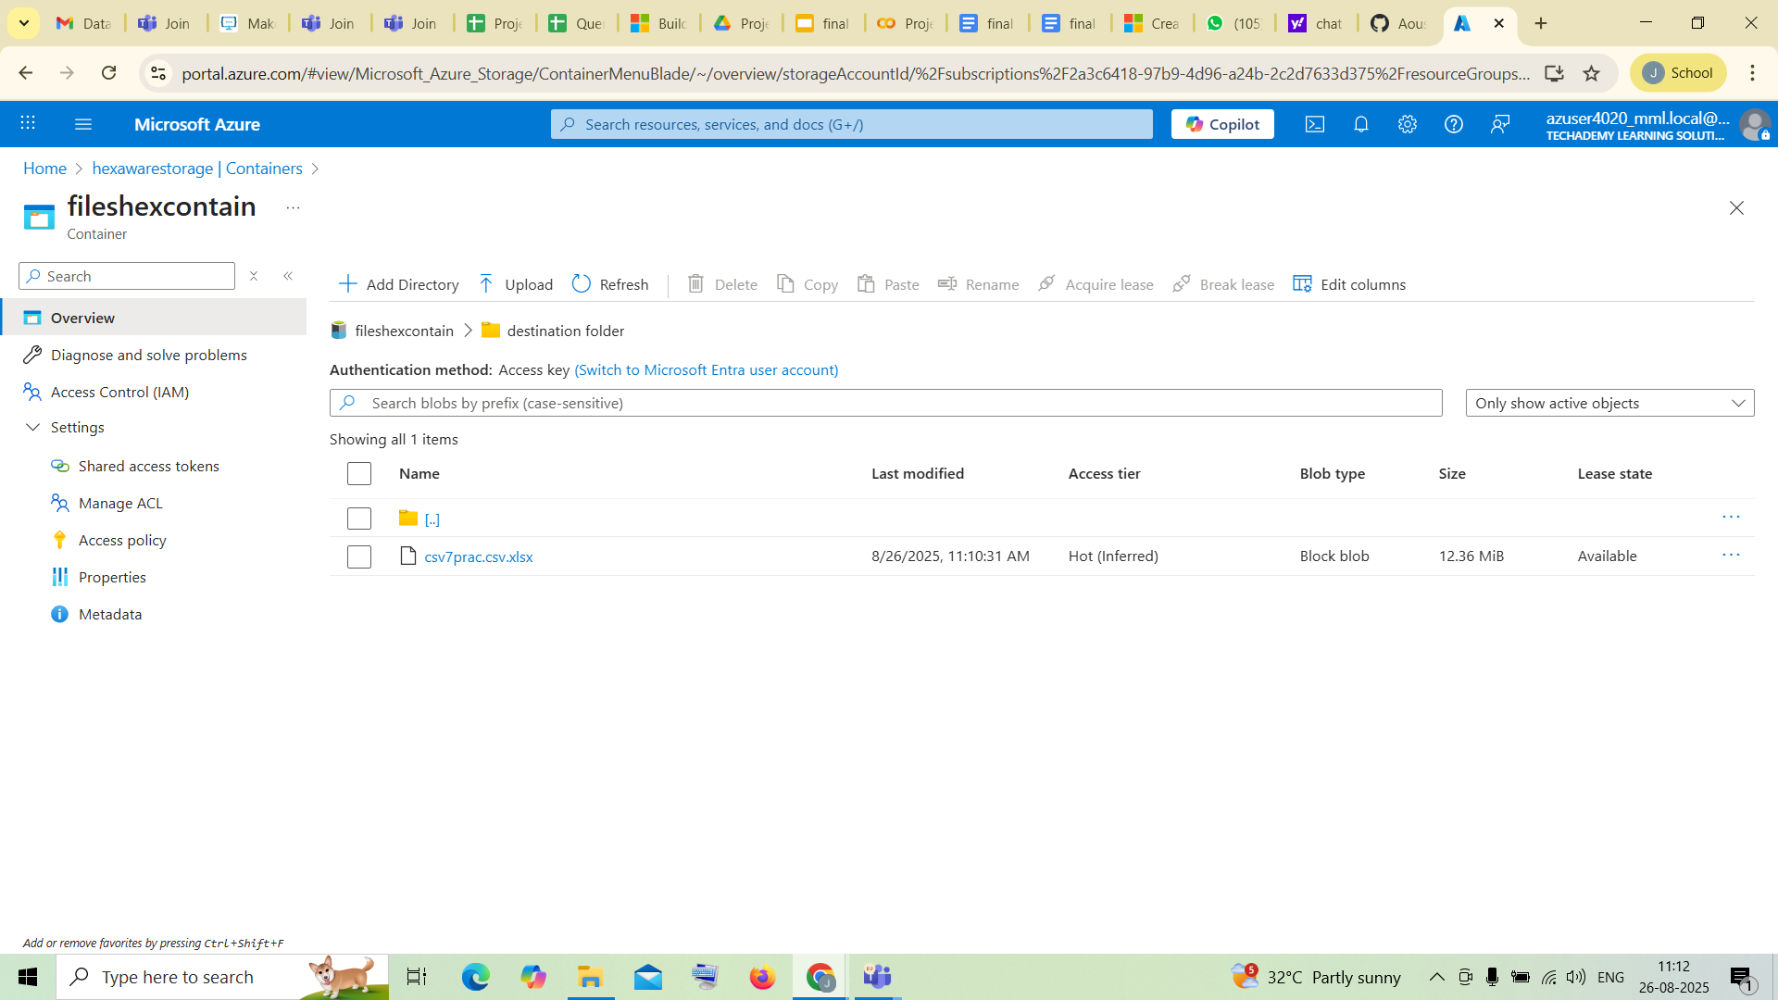

Strategies that can be used in Optimising the Conversion process:

a. Enhance ADF Pipeline Performance
- Right-fit data movement and runtime selection: Choose between Copy Activity, Mapping Data Flow, or event-driven options (Azure Functions, Logic Apps) based on workload complexity. For large data transfers, use Parallel Copy and prefer Parquet over CSV for compression and efficiency.
- Leverage parallel processing: Use ForEach and Lookup activities to segment workloads and parallelize tasks. Partition your data intelligently to distribute load evenly.
- Optimize transformations: In Mapping Data Flows, apply partitioning, push-down filters to source systems, and cache intermediate results to reduce processing overhead.

b. Scale Data Movement & Storage
- Optimize ingestion throughput: Use ADF’s Parallel copies setting, tune block sizes, or use DistCp to increase data throughput.
- Use premium storage tiers: If consistent low latency and high IOPs are critical, deploy ADLS with premium block blob storage. This SSD-backed tier provides significant performance gains at a somewhat higher cost.
- Structure your data lake efficiently: Organize data hierarchically, employ partitioning, and use columnar or compressed formats to reduce scan times and storage costs.

c. Monitor, Diagnose, and Tune
- Continual Performance Monitoring: Utilize ADF’s monitoring dashboards alongside Azure Monitor and Log Analytics to track throughput, execution time, DIUs, and resource consumption.
- Optimize based on insights: Identify bottlenecks via diagnostics and adjust resource allocations, parallelism, or activity configurations accordingly.

d. Cost Efficiency & Incremental Loading
- Avoid full data loads when possible: Implement incremental loading using CDC or timestamp-based filters to reduce unnecessary processing and transfer costs.
- Tiered storage and data lifecycle: Automatically transition less-frequently accessed files to cooler tiers and clean up stale data via lifecycle policies, reducing storage costs.

e. DR & Resilience Optimization
- Geo-replication & targeted syncing: Use Azure Storage geo-replication (like GZRS or RA-GZRS) for automated disaster resilience. Complement this with ADF pipelines to selectively replicate critical datasets.
- User-managed CI/CD-based recovery: Maintain a full CI/CD setup that allows redeployment of ADF artifacts in secondary regions or zones in case of failures.
Conclusion:
This integration provides a robust, scalable, and auditable architecture for managing data pipelines. By leveraging Git-based version control in Azure DevOps, ARM template-driven CI/CD, and ADF pipelines targeting ADLS, organizations gain agility, repeatability, and compliance. It's a mature pattern that supports enterprise-grade data movement and delivery workflows in Azure.
- High Performance: Through parallelism, optimized formats, and premium storage, your conversion pipeline scales efficiently.
- Cost Control: Bottom-line improvements result from incremental loading, tiered storage, and targeted replication—even while safeguarding resilience.
- Operational Reliability: Monitoring, diagnostics, and structured CI/CD ensure consistency, traceability, and quick recovery across environments.
- Future-Readiness: A flexible, modular design allows you to evolve—adding advanced transformations, analytics, or governance without disrupting existing pipelines.
In sum, a well-optimized Data Factory plus ADLS ecosystem is not just about moving data, it’s about managing it smartly, securely, and sustainably.

